Mobile APP

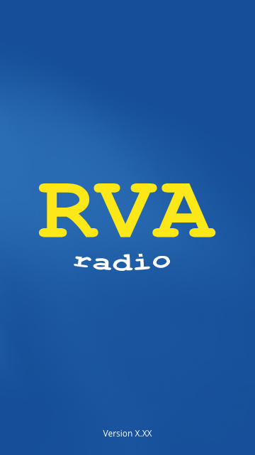

After splashscreen (Screensplash must display number of version at the bottom
), at launch, the application opens the home page.
At launch, the radio player is RVA premium and the sound is in the OFF mode.

- After 3 times using the app the user is asked with a pop up : « RVA – Si vous aimez cette application, laissez-nous un petit commentaire et une bonne note sur le store. Merci de votre support! » with an option « Noter (that leads to the store link in API) – Plus tard (that shuts the pop up and will ask in 3 times) – Jamais (in that case never propose that pop up again). (TEXT COMING FROM API)

- When you are on home page and press to the return button you should get a popup asking : “ RVA – Voulez-vous vraiment quitter cette application?” “OUI– NON ” if the answer is “oui” app must shut down, if “non” the popup shuts and the user stays on the home page (text COMING FROM API)

- CAUTION: we also want that the following informations to be displayed via Bluetooth : “Name of the radio + artist + tittle”

- Only one interstitial Add should come at launch – if it’s a video sound please make sure sound of the radio shuts down for the duration of the ad – there should NEVER be 2 sounds at the same time on the app. (same for podcasts and radio) (code for google ads COMING FROM API) (Google ADD SDK – codes in the API)

- Add also the following SDK :

1 – AT INTERNET analytics (CODES COMING AT THE END OF THE DOC)
2 - Highconnexion NOTIFICATIONS (CODES COMING AT THE END OF THE DOC)
CAUTION : for notifications (versus Highconnexion) documentation will be sent with other elements. Deeplinks for notifications must now be implemented.

EXEMPLE url :

https://xd.adobe.com/view/438c5022-f26c-4b7f-91ad-1b1e712eb3dd/?fullscreen

Keys for API : given on a special file

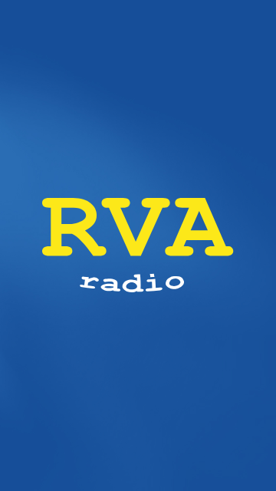

HOME PAGE

This page consists of the player and the list of Internet radio stations + contact /share / get on playlist menu + global menu

Caution : A smaller mobile screen must be able to see at least ONE webradio and a half (2 and a half on picture)

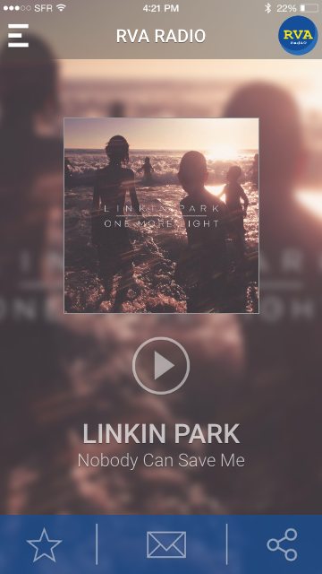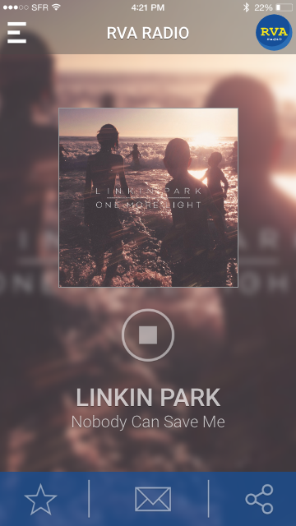

On air is displayed when the radio is played – the good logo is displayed on the top right
CAUTION : please check if no webradio comes from the API then display no radio – this must be dynamic

THE NAV BAR

Navbar is made of:
• Burger menu on the left
• The name of the current radio played (the same that is ON AIR) in the center
• The logo of the played radio on the right (RVA at the beginning) – when you click on the logo from any page you come back on the radio player page

THE PLAYER :

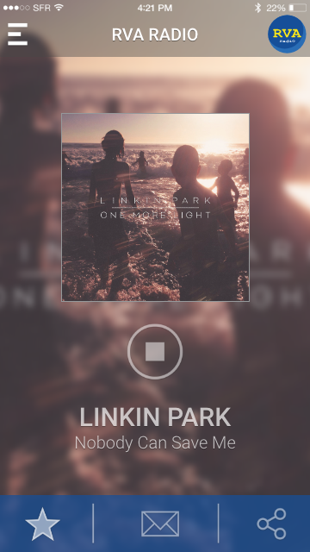
It consists:

• The logo and name of the played webradio

• The visual of the cover (picture sleeve) and the current title information (artist's name and song title) which are recovered from a stream of the API – CAUTION : underneath the background is blurred

• A Play / Stop button (No "Pause" button as no management streaming)

On one line below:
• A Sharing button : to click ALL sharing possibilities in the phone (text coming from API – see example BELOW)

• A Favorites button. (On click, it put the title played in the playlist page) it has to be synchronize with the star in the list of playlist page

• A contact button * send in API

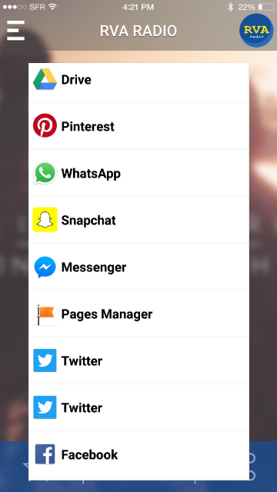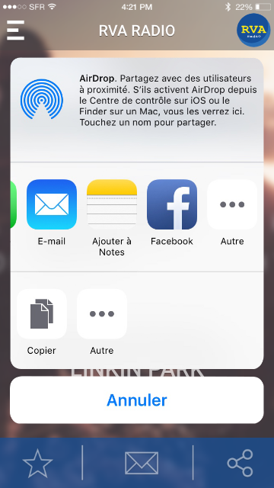

THE INTERNET RADIO LIST :

The first radio listed is RVA
The following radios are defined in the flow of webradios from the API .

Each cell is composed list :
• The logo of Internet radio (on left when played with “on air” on the right when played)
• The current title information (artist’s name and song title )

The radio played must have its logo on the right– the others must have a logo on the left and artist / title written on the right – the radio played must display ON AIR on the left

The player zone is not fixed : when the user scrolls the list webradios down, the player scrolls along the list.

When you click on a webradio to listen to it, the screen gets up to the big player and it plays the chosen radio

The texts shall be in 2 lines max otherwise add 3 dots (…)

Blured background come from the graphic elements

CAUTION : At this time the list of webradios is empty. In this case do not display any internet radio list. The radios must be displayed when list contains at the least 2 webradios. Counting mut be done from the API.

MENU BURGER ON TOP LEFT

On clicking the Burger menu, the whole page shifts to the right to display the menu

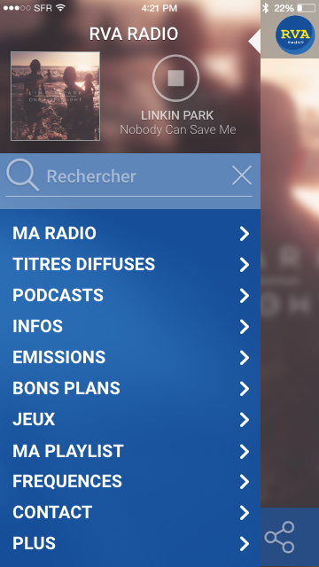
A MINIPLAYER at top

A SEARCH BAR

A MENU which has 10 tabs, grouped as follows
- Ma radio

  - Titres diffusés
  - Ma playlist
  - Podcasts
  - Infos
  - Émissions
  - Bons Plans
  - Jeux
  - Fréquences
  - Contact
  - Plus

At the top of the menu a mini player plays the radio

The menu includes a search function (rechercher) which is in the form text field.
By clicking on button "Rechercher" of the keyboard, the user is redirected to the page RECHERCHE.

RESULT OF RESEARCH

Caution the search field recalls at least 2 letters (otherwise text is “Au moins 3 lettres pour votre recherche SVP”)

It is possible to do a new search directly from this page by entering a new expression directly into the search field and launching research via the button « rechercher » (search) of the keyboard – don’t forget to put a cross to cancel the search

Keyboard must disappear when search is launched

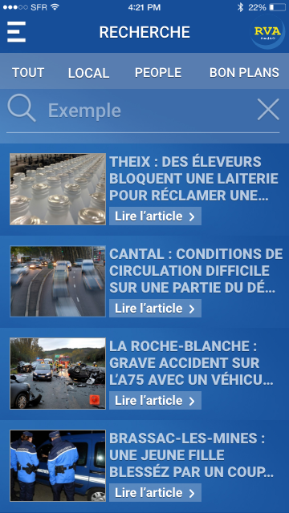
The results are displayed as a list of articles

We charge only the first 10 items, then if you go down to the bottom of this list the following 10 were charged, etc.

Presentation of articles:

• the article are centered in the photo on the left.
• We see only the first 3 lines of the title followed by three dots if the title is longer.
- Under each article when you press “Lire l’Article” the article can be read
- When you click on a new article the old one shuts

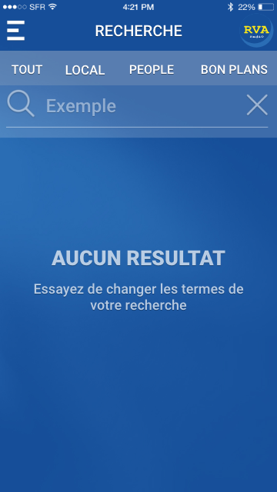
IN CASE OF NO RESULT

You filter your search by “NEWS”

If you type a word to research a cross is displayed on the right and you can delete your search by cliking on it (example with Exemple on the picture above)

Page MA PLAYLIST

The page consists of a list of artists /titles that the user has added to favorites.
On the left : page without any “favoris” (titles putted in the user playlist)

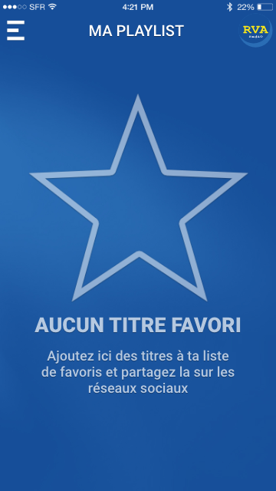
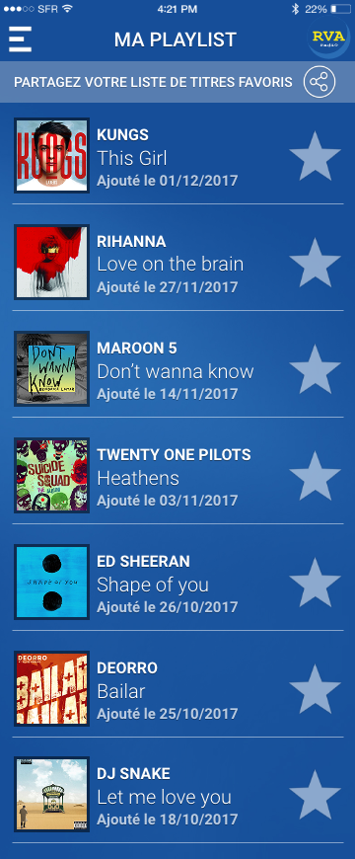

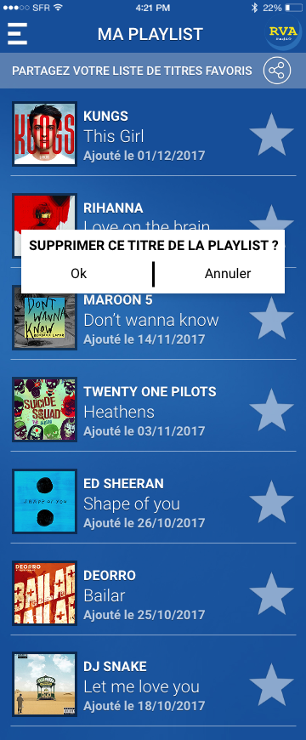
Each list item consists of:
- a sleeve picture
- The name of the artist
- The title
- A plain star

If you clic on a plain star you can delete a title from your favorites with a message “ RVA – SUPPRIMER CE TITRE DE VOTRE PLAYLIST ? OK – ANNULER” if user press OK” title is deleted – if “ANNULER” page remains the same
There must be a possibility for the user to share his playlist on the different sharing option of the mobile (*text down)

A specific page is provided in case the user has not defined favorite item (“Aucune playlist – Ajouter ici vos titres favoris” – image up this)

PAGE PODCAST

This page consists of a list of podcast categories

- Each category consists of:
- Visual ot the category
- the title of the category
- The number of podcasts that contains the category (COMING FROM API)

On click on a category the user is redirected to the page LISTE DE PODCASTS

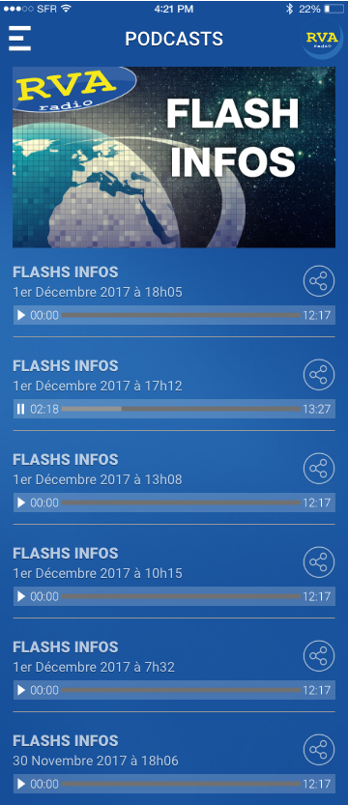
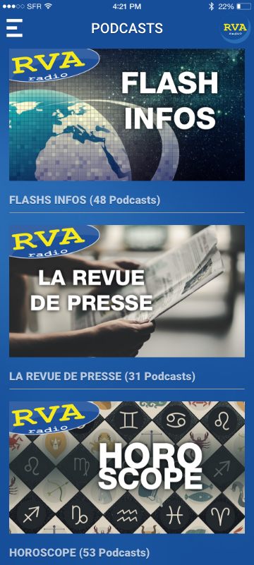

Page LISTE DE PODCASTS
This page consists of:
• a visual of the selected category
• a list of podcasts

The presentation of each podcast consists of:
• its name
• its description (date)
• a player
+ A possibility to share by ALL the existing possibilities of the mobile *see message below

We charge only the first 10 podcasts, and if we descend to the bottom of this list the following 10 were charged, etc.
At the click of a podcast:
• Podcast sound is launched by clicking on a play button of the player
• if an Internet radio is playing, it must stop
* If you launch another podcast (via a second player on the same page) the sound of the first sound stops
In any case you CAN NOT read 2 sounds at the same time
Podcasts sounds do not load until the user has not clicked on a podcast.

PAGE “INFOS”
This page consists of a 3 choices menu:
- A LA UNE (the same as in the list of articles) by default
- METEO ( weather forecast) displayed from API
- PEOPLE
at the top you can find the latest INFO podcast with recorded time / a sharing button / a play-pause button

A LA UNE (by default) and PEOPLE pages consist of a list of articles with:
• the main picture cropped to the dimensions specified in the design
• The title of the article
• a possibility to discover the article by opening the tile by clicking on “Lire l’article”

CAUTION : You get on each news page a podcast of the latest info flash to play ( “le dernier FLASH INFO” ) The default "Info locale" tab is active. It includes ALL the RVA local articles.
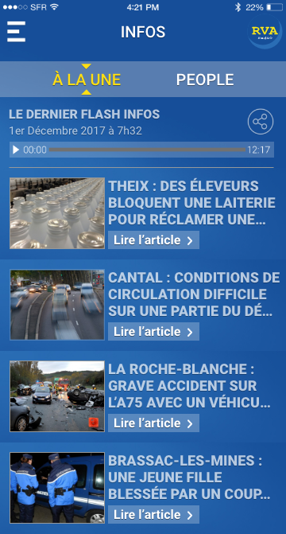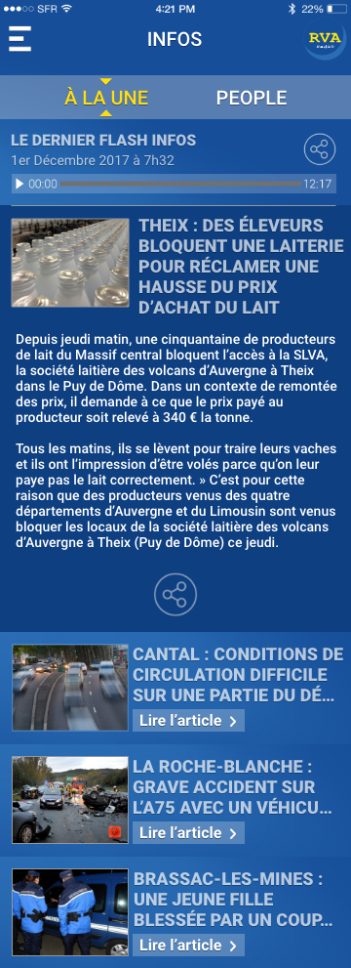
Inside an article :
- Article
- Sharing Icon that opens all the avalaible possibility of sharing on the phone the article (social networks apps, sms, mail…*see message of sharing articles (TEXTE COMING FROM API)
- Photo

Page EMISSIONS

This page consists of:
• the DATE (beginning with todays date)

Each cell is expandable list. On click, the cell opens and displays the text description of the program. The arrow changes direction (facing up).
When you click on the cell of a program, that cell opens and the previous open cell closes.

• A list of RVA programs
Every cell in the program list is made of:
• The visual of the show
• The title of the program
• days and hours of the program

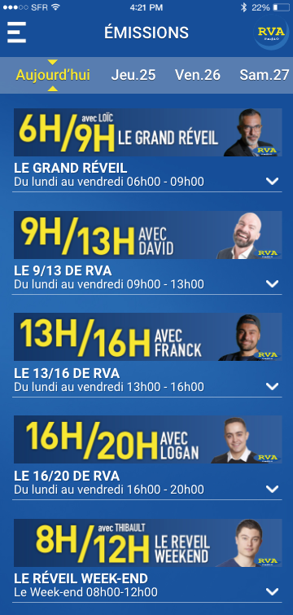• On an 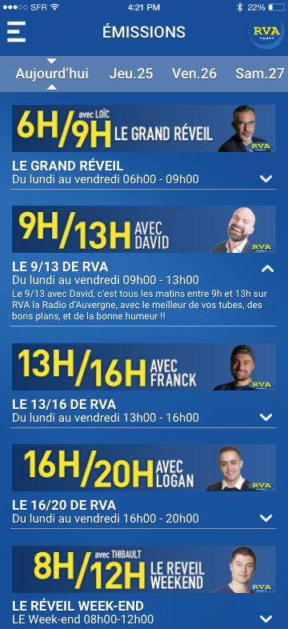arrow (pointing down) that magnifies the cell
Page BON PLANS

This page proposes 2kinds of BON PLANS: BON PLANS / CONCOURS (concours are also displayed live on the JEUX page)

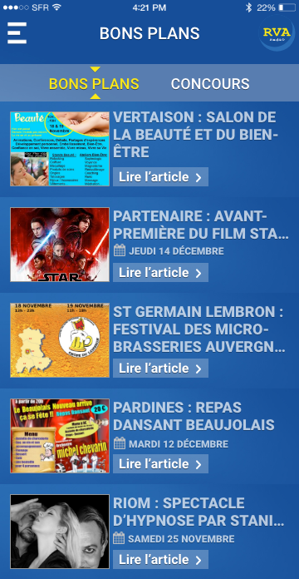
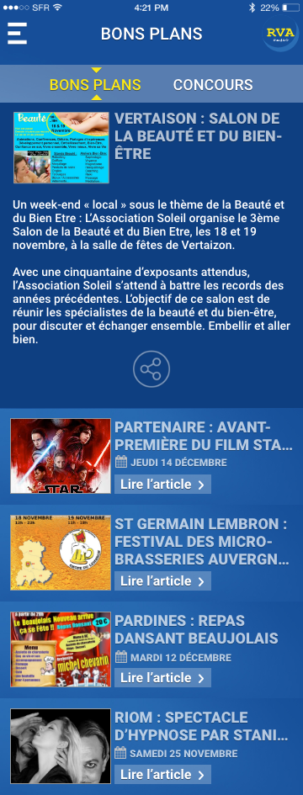
Page JEUX

PAGE MUST BE PREPARED – CONTENT is coming from the Highconnexion SDK

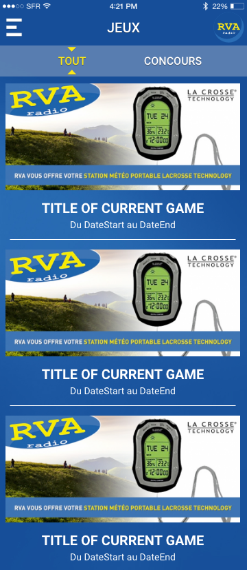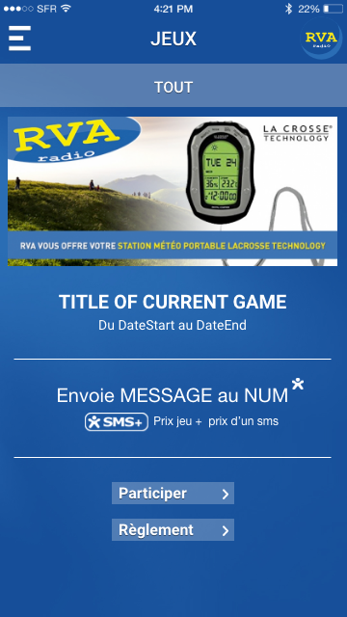

Under the games displayed by High connexion SDK we must place our “concours “ (games) displayed on “concours” page

Page TITRES DIFFUSES

This page consists of a search form and expandable list of day/time/ internet radio.
- The search form:

This form allows you to search by title: time and the selected Internet radio
* Days – begins by “Aujourd’hui” (today) and if pressed display the phone calendar
• Time: drop-down hours round (results are displayed on an hourly hour range)
• Internet radio: drop-down list of names of Internet radio. The first in the list is RVA
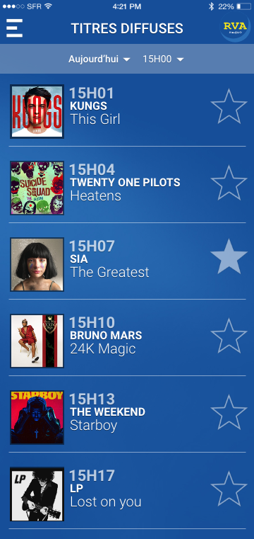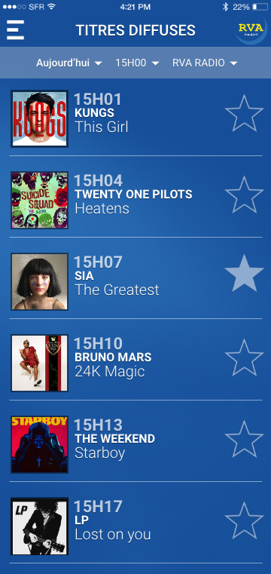
The user chooses at the top when and on what radio he wishes to see the program. (if only one radio do NOT display the choice like on the left if 2 radios or more display like on the right)

- When the demand comes in the same time slot :
Results are displayed for the actual time to the beginning of the hour and the first half an hour before (example from 15h34 to 14h34)

- When the demand does not come in the same time slot :
Results are displayed from the beginning of the asked hour to the end of the asked hour (example from 14h00 to 15h00)

You may slide to get the whole hour of titles
By default is displayed the program of the current time on RVA from the beginning of the current hour.
Informations come from API
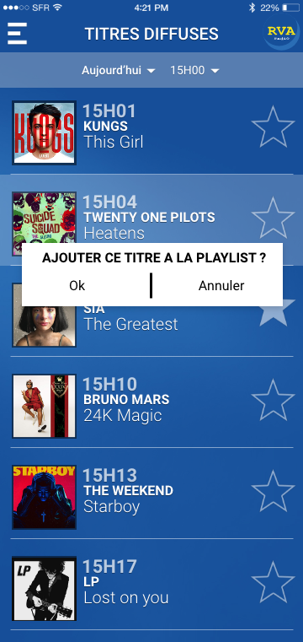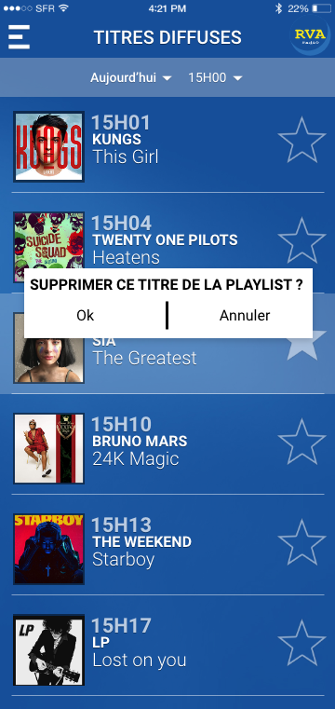
If you press a star a message comes “ Ajouter ce titre à votre playlist? OK – Annuler » if ok then title is listed in the playlist – if « annuler » operation canceled

Page MA PLAYLIST

Each title includes:

• Visually Cover (picture sleeve)
• From the time it was played (“ajouté le” + DATE)
• The current title information (artist name and song title)
* a favorite star on the right, which can be unfilled when it is clicked
If the star is plain it means the title is in the user playlist.

If you press a star a message comes “ Suppimer ce titre à votre playlist? OK – Annuler » if ok title is delayed in the playlist – if « annuler » operation is canceled

Page FREQUENCES

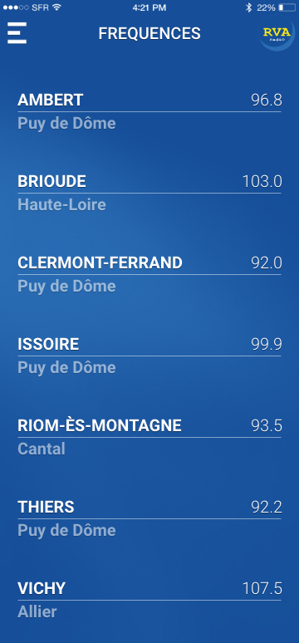
This page is composed of a geographical area selector (filter) and a list of radio frequencies of la Radio PLUS

Each cell consists of:
• The name of the city in white
• The department in grey
• the frequency (centered as on the example on the left)

This list is static, no action is expected to click on a cell.

Data coming from API

Page CONTACT
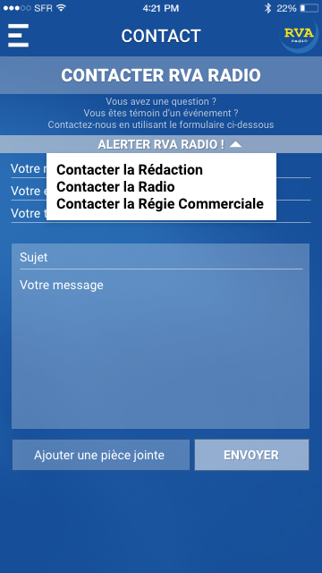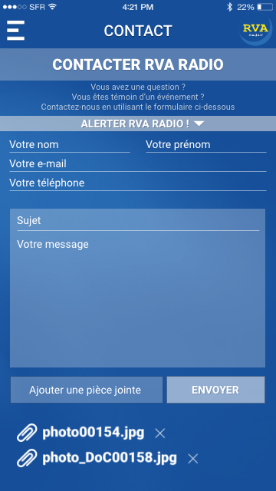
This page is created to contact various departments of RVA and send one attachment piece

This page consists of:

- An explanatory text in header (see picture)
- A drop-down list of possible recipients (« Alertez RVA ! » / « contactez la rédaction » / « contactez la radio » / « contactez la régie commerciale »… coming from the API )
- The fields "email" and "message" are mandatory, the rest is optional. * Below error message to display from the API
- A button « Ajouter une pièce jointe »
- A button « Envoyer »
- A text that provides additional information on contact details coming dynamically from API
After selecting attachments, they are visible in the text field. The user can remove them as erasing a text or send them by clicking the button « Envoyer ».

If the user clicks on the button « Envoyer » without having previously completed the required fields, then an alert will warn the user that he must first complete the missing information. * see error message below (TEXT COMING FROM API)

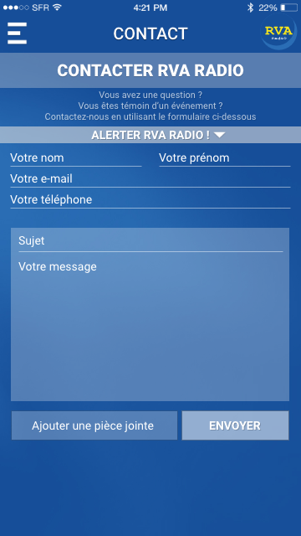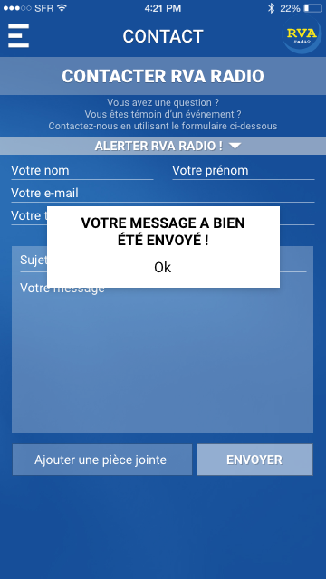

Once message has been sent a message comes : “Votre message a bien été envoyé !” (message has been sent)

Page LES PLUS

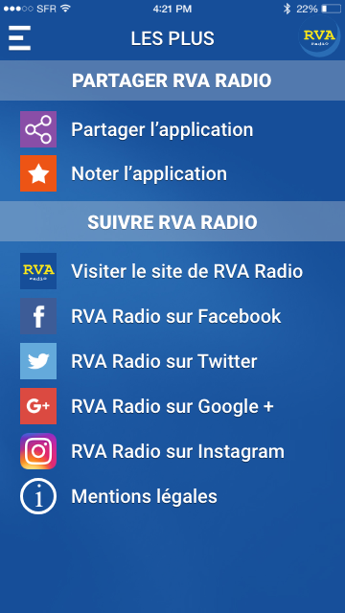
This page allows the user to follow RVA via the website and social networks, and share application RVA

Section PARTAGER RVA :

- On click on « Partager l’application», the app opens ALL the sharing oportunities proposed on the phone –*sharing text below (TEXT COMING FROM API)
- On click on « Noter l’application », App stores opens on the application page (coming dynamicly from API)

Section SUIVRE RVA : (coming dynamicly from API)

  - « Visiter le site RVA» goes to internet website
  - « RVA sur Facebook » goes to Facebook de RVA
  - « RVA sur Twitter » goes to Twitter de RVA
  - « RVA sur Google + » goes to Google + de RVA
  - « RVA sur Instagram » goes to page Instagram de RVA

- With mention légales you display a page sent by the API a responsive way

Page ALERTE INFO
This alert may appear at any time and on any page. After 6 seconds this alert info disappear (same as lyonmag application) and will be displayed on the next page seen for 6 seconds... etc... If the user clic on the cross, this alert wont be displayed until the end of navigation.

This Alerte Info is made of :
- a header « ALERTE INFO »
- A cross for closing the insert
- Title of the article limited to 3 lines (if it is longer, the third line ends with 3 dots)
- A button « Lire la suite ». On click, the user is redirected to the page of the concerned ARTICLE inside the app

The inset appears by sliding from the bottom of the screen, over the mini-player, and goes down in the same manner. By default, the insert is displayed for a period of 6 seconds before disappearing.
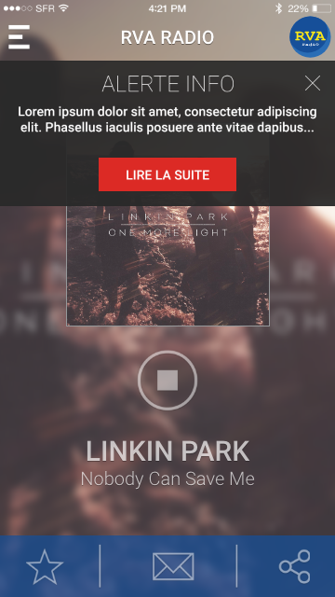

Some information may be reported as an alert. If nothing comes from the API please often check and don’t display anything
Texts coming from API :

Sharing from the RADIO page :
« J’écoute un titre sympa en ce moment sur l’application RVA ! »
+ Artist playing / Title playing
“L’application RVA est disponible gratuitement pour Android et IOS

+ put picture of the sleeve of the artist/title playing

Sharing from the PODCAST page :
« J’écoute un podcast sympa en ce moment sur l’application RVA ! »
+ title of podcast playing
“L’application RVA est disponible gratuitement pour Android et IOS

+ put link to chosen podcast

Error message from Contact page
When the "E-mail" field is blank, the alert text is: " RVA - Merci de bien indiquer votre email "
When the "E-mail" seems wrong, the alert text is: " RVA - Votre email semble être non valide "
When the "Message" field is blank, the alert text is: " RVA - Merci de bien indiquer votre message "

Error message in case of wrong joined file :
« Attention ! ce document ne pourra nous parvenir car il semble non valide. »

Sharing from the PLUS page :
« J’ai découvert une radio EXCEPTIONNELLE !!!
L’application RVA est disponible gratuitement pour tous les smartphone !»
+ put picture of the logo

Sharing from the ARTICLE page :
object : « Article sympa sur l’appli RVA ! » (ONLY FOR EMAIL sharing)
text : Title of the article …. “Article sympa trouvé sur l’application mobile RVA : »
URL of the article + picture of the article (if possible)
« (disponible aussi sur le site : www.radiorva.com) »

RESUME OF SDKs and TAGS that must be included:

1 – SDK STATISTICS : AT INTERNET – Mediamétrie
documentation in French here :
http://documentation.atinternet.com/AT_UG_API_Rest_2_FR.pdf
Tags : ID Coming from API

2 – SDK PUSHS / NOTIFICATIONS - HIGH CONNEXION
See document in French sent with the specific file

3 – SDK GOOGLE ANALYTICS -> cf API

4 – SDK ADVERTISEMENT GOOGLE AD SERVER -> cf API

5- SDK - ADSWIZZ
https://www.dropbox.com/sh/2r7hzvgbfrf4f5c/AACJ2VZT9ROcJLFBh-Ju8tTla?dl=0
COmme installation id, merci d’utiliser espace_iosapp (pour ios) et espace_androidapp (pour android).

TAG REVIEW ON THE STORE

TAG DIPLAY OF TITLES/ARTISTS/NAME OF RADIO VIA BLUETOOTH

MODEL HERE : https://xd.adobe.com/view/438c5022-f26c-4b7f-91ad-1b1e712eb3dd/?fullscreen

CAUTION :

App wont be considered as fulfilled if the following point have not been done :

For android:
• Use the lib VLC (As on Allzic).
• Implement the player in the notification bar.
• Manage phone sleep modes (WakeLock, PowerManager). The app should always turn when the phone goes to sleep. Disabled the Wifi break.
For all app
• Put Bluetooth well – name of the radio + logo + artist /title
• Manage the various interruptions (incoming call, outgoing calls, ...)
• Do not implement Estat but AT-Internet in level 2 tag
• Implement Google Ads Via DFP
All main informations MUST come dynamically from the API. (Nearly nothing must be hard coded )

